

Princess Sumaya University for Technology Computer Engineering Department *Embedded Systems & Microprocessors*

“Obstacle Removing Robot”

*First Semester 2024*

**Team Members**

**Student IDs**

**Majors**

**E-mail**

Qutaiba Hamdan

20190638

Assem Shuibat 20190563

Communications Engineering

Communications Engineering

[qut20190638@std.psut.edu.jo](mailto:qut20190638@std.psut.edu.jo)

[ass20190563@std.psut.edu.jo](mailto:ass20190563@std.psut.edu.jo)

**Abstract**

*This project revolves around the development of an obstacle-removing robot, driven by a PIC16F877A microcontroller. The robot is equipped with a Sharp IR sensor and a servo motor to facilitate obstacle detection and removal. The primary goal is to enhance the robot's navigational capabilities in dynamic environments.*

# Table of Contents

Table of Contents

I. Introduction

A. Project Overview................................................................. 4

B. Objectives and Scope......................................................... 4

II. System Architecture

A. Microcontroller PIC16F877A............................................... 6

B. Sharp IR Sensor............................................................... 8

C. Servo Motor for Lifting Mechanism........................................ 9

D. Chassis, Motors, and Wheels............................................... 10

III Software Design 11

VII. Electrical Design and Results 12

V. Conclusion 13

# Introduction

# A. Project Overview

# The obstacle-removing robot project represents an innovative venture aimed at enhancing the capabilities of autonomous robotic systems. In response to the growing demand for intelligent and adaptable robotic solutions, this project focuses on the development of a versatile robot capable of autonomously detecting and removing obstacles in real-world environments.

# B. Objectives and Scope

# The primary objectives of this project are twofold: first, to design a sophisticated robotic system capable of effectively detecting obstacles using a Sharp IR sensor; and second, to implement a robust lifting mechanism using a servo motor for obstacle removal. The scope of the project encompasses the integration of key components, including the PIC16F877A microcontroller, the Sharp IR sensor, and the servo motor, to create a seamless and efficient obstacle-removing robot.

# By combining advanced sensor technologies with precise control mechanisms, the project aims to achieve a reliable and adaptive robotic system that can navigate through complex environments, identify obstacles accurately, and employ a lifting mechanism for their removal. The successful implementation of this project promises practical applications in various domains, such as automation, surveillance, and logistics, where autonomous obstacle removal is a critical operational requirement.

Figure 1 depicts the block diagram of the designed project.

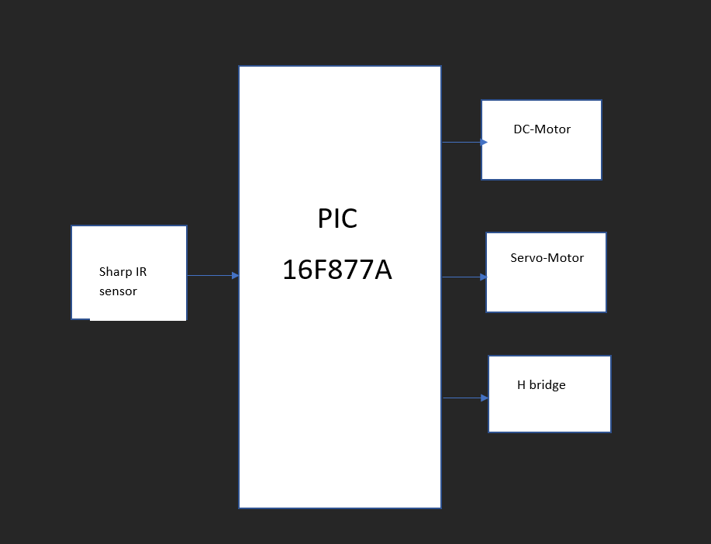

*Figure 1*

# An Overview of the Used Components

This section will briefly discuss the components we used in our project and how we were able to implement them..

### The Microcontroller PIC16F877A[1]

The central processing unit of our obstacle-removing robot is the PIC16F877A microcontroller. This versatile microcontroller serves as the brain of the system, responsible for coordinating and controlling various aspects of the robot's functionality. Its extensive range of features, including multiple input/output pins, analog-to-digital conversion capabilities, and programmable functionalities, make it an ideal choice for handling the intricate tasks required for obstacle detection, navigation, and lifting mechanism control.

The PIC16F877A microcontroller interfaces with and manages other system components, ensuring seamless communication and coordination. Its programming logic is tailored to integrate inputs from sensors, process data, and execute precise control signals to the servo motor, providing the robot with the necessary intelligence to navigate and remove obstacles effectively.

The PIC16F877A is a microcontroller that has 40 pins. It is widely used across many fields such as electronic applications, industrial control, and in the automotive industry. It consists of 35 I/O pins and has many built-in functions such as Timers, ADC, PWM. It also has 8K of program memory and 368 bytes of RAM. It is extremely easy to use hence the reason its a popular choice

Figure 2 depicts the PIC16F877A and its output pins.

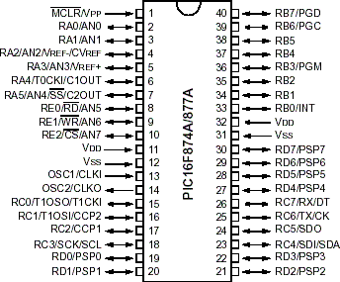

### Sharp IR Sensor

The obstacle detection system relies on a Sharp IR sensor, strategically positioned at the front of the robot. This sensor employs infrared technology to measure distances accurately and detect obstacles within its field of view. By continuously scanning the surroundings, the Sharp IR sensor provides real-time distance data to the microcontroller, enabling the robot to make informed decisions about its path and the presence of obstacles.

The integration of the Sharp IR sensor enhances the robot's situational awareness, allowing it to adapt its navigation based on the proximity and size of detected obstacles. The sensor's high precision and rapid response contribute to the robot's ability to operate in dynamic and unpredictable environments.

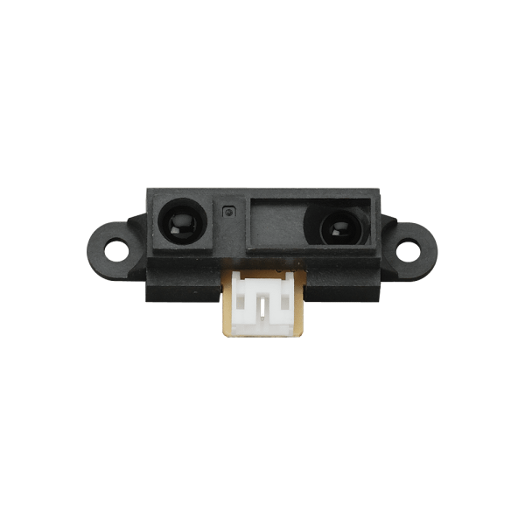

*Figure 3:* *Sharp IR Sensor*

### Servo Motor[4]

A servo motor is employed as the lifting mechanism for obstacle removal. Connected to the PIC16F877A microcontroller, the servo motor is responsible for controlling the vertical movement of a specialized tool designed for obstacle removal. The servo motor's precise angular control enables the robot to lift the tool when encountering obstacles, facilitating their removal without compromising the robot's stability.

The lifting mechanism, orchestrated by the servo motor, provides the robot with the capability to adapt to different obstacle sizes and shapes. This dynamic response ensures efficient obstacle removal while maintaining the robot's overall balance and stability.

A servo motor can be used to move an arm from 0 to 180 degrees. The servo motor works based on PWM, this means that the angle that it rotates is controlled by the width of the pulse applied to its control pin. The MCU will output the angle via the control pin.

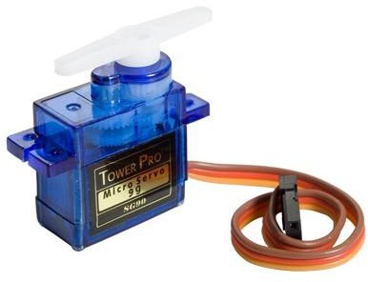

*Figure 5 Servo Motor*

### Chassis, Motors, and Wheels

The physical structure of the robot consists of a durable chassis equipped with motors and wheels. These components are crucial for the robot's mobility and maneuverability. The integration of motors and wheels allows the robot to navigate its environment with agility, responding to input signals from the microcontroller based on sensor data.

The chassis provides a sturdy framework for mounting and securing various components, ensuring the stability and integrity of the robot during its operation. The combination of chassis, motors, and wheels forms the foundation for the robot's dynamic movement, allowing it to traverse diverse terrains and effectively reach areas with obstacles

Software Design

Figure 7 depicts the flowchart that describes the designed project.

*Figure 7 Flowchart of the designed system*

# Electrical Design and Results

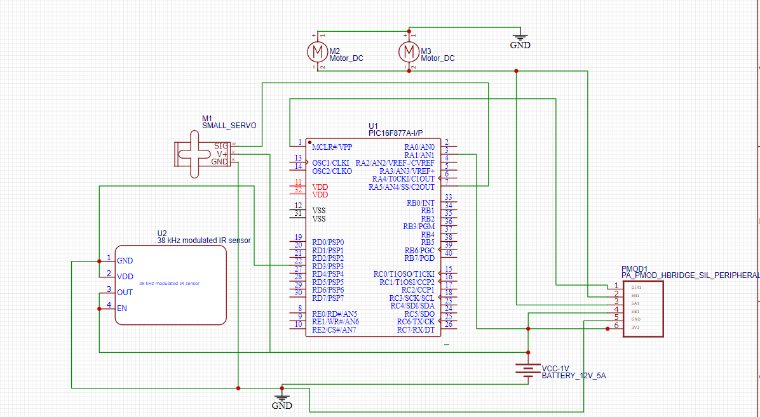

*Figure 8 Obstacle Removing Robot Hardware Design*

After designing the circuits and testing the code this is what the final project looks like.

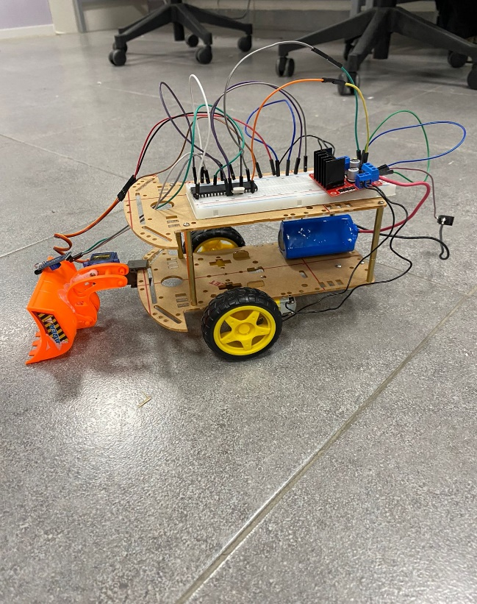

*Figure 9 Final Result*

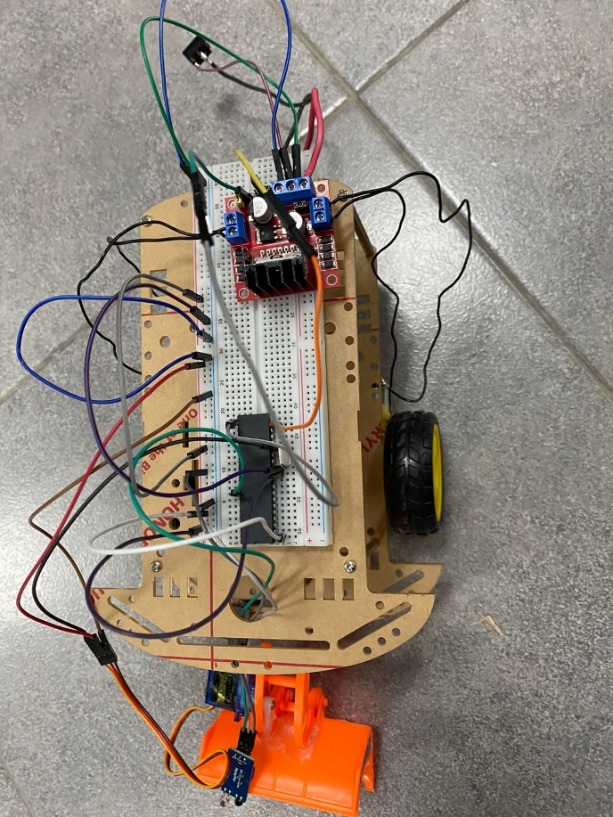

*Figure 11 Top view*

# Conclusion and Problem Identification

# The culmination of the obstacle-removing robot project marks a significant stride towards the development of an intelligent and adaptive robotic system. The integration of advanced technologies, such as the PIC16F877A microcontroller, Sharp IR sensor, and servo motor, has resulted in a cohesive and efficient robotic platform designed for autonomous obstacle detection and removal.

# Summary of Achievements:

# **Obstacle Detection and Removal:**

# The implementation of the Sharp IR sensor has endowed the robot with the capability to accurately detect obstacles in its path.

# The servo motor-driven lifting mechanism exhibits precision and reliability in the removal of obstacles, showcasing the adaptability of the robot to various scenarios.

# **Microcontroller Intelligence:**

# The PIC16F877A microcontroller serves as the neural hub of the system, orchestrating seamless communication between sensors, motors, and the lifting mechanism.

# Its programmability and integration capabilities have been leveraged to create an intelligent decision-making system that enables effective obstacle navigation.

# **Dynamic Mobility:**

# The chassis, motors, and wheels contribute to the robot's dynamic movement, enabling it to navigate diverse terrains and effectively reach areas with obstacles.

# The power supply system ensures consistent energy distribution, enhancing the robot's endurance during extended operations.

# Identified Challenges and Solutions:

# **Obstacle Detection Accuracy:**

# Despite the overall success in obstacle detection, challenges related to accuracy in certain environmental conditions have been identified.

# Future improvements may involve sensor calibration adjustments and the exploration of additional sensor technologies to enhance accuracy.

# **Lifting Mechanism Reliability:**

# The lifting mechanism, driven by the servo motor, exhibits reliability; however, there are instances where optimization is necessary for handling specific obstacle shapes or weights.

# Further refinement of the lifting mechanism's control algorithm and potential adjustments to the servo motor's torque may address these challenges.

# **Recommendations for Future Enhancements:**

# **Sensor Upgrades:**

# Consider exploring advanced sensor technologies or incorporating a multi-sensor fusion approach to enhance obstacle detection accuracy and reliability.

# **Enhanced Navigation Algorithms:**

# Develop more sophisticated navigation algorithms to improve the robot's adaptability to complex and dynamic environments, ensuring optimal obstacle avoidance and removal strategies.

# In conclusion, the obstacle-removing robot project has achieved its primary objectives and demonstrated a promising foundation for future advancements. The identified challenges provide valuable insights for iterative refinement, paving the way for a more robust and versatile robotic system capable of overcoming a wider range of obstacles in real-world scenarios.

# References

1. Microchip Technology Inc. (2001). PIC16F87XA Data Sheet:

[https://www.microchip.com/en-us/product/PIC16F877A]

2. Sharp Corporation. (n.d.). Sharp IR Sensor Datasheet.: [https://www.sharpsde.com/products/optoelectronics/pdf/datasheet/gp2y0a41sk_e.pdf]

1. Tower Pro. (n.d.). SG90 Servo Motor Datasheet.: [http://www.ee.ic.ac.uk/pcheung/teaching/DE1_EE/stores/sg90_datasheet.pdf]
2. National Instruments. (2008). Fundamentals of Servo Motion Control.:

[https://www.ni.com/en-us/innovations/white-papers/08/fundamentals-of-servo-motion-control.html]